**(L1F22MBAM0060)**

|  |  |  |  |
| --- | --- | --- | --- |
| date | sentiments | analysis | Average of 7 days |
| 6/2/2023 | neutral | 0.58518 |  |
|  | neutral | 0.494423 |  |
|  | neutral | 0.58518 |  |
|  | neutral | 0.599664 | 0.58987 |
|  | neutral | 0.496713 | 0.599114 |
|  | neutral | 0.58518 | 0.626764 |
|  | positive | 0.838675 | 0.560705 |
|  | positive | 0.89531 | 0.57339 |
|  | negative | 0.256719 | 0.563449 |
|  | neutral | 0.521726 | 0.581446 |
|  | neutral | 0.572179 | 0.55281 |
|  | positive | 0.647489 |  |
|  |  |  |  |
| 5/2/2023 | neutral | 0.522499 |  |
|  | neutral | 0.582497 |  |
|  | neutral | 0.476294 |  |
|  | neutral | 0.500205 |  |
|  | positive | 0.932039 |  |
|  | neutral | 0.506292 |  |
|  | negative | 0.393655 |  |
|  | neutral | 0.513254 |  |
|  | positive | 0.673467 |  |
|  | neutral | 0.45459 |  |
|  | positive | 0.678889 |  |
|  | positive | 0.95569 |  |
|  |  |  |  |
| 4/2/2023 | positive | 0.629135 |  |
|  | positive | 0.883272 |  |
|  | neutral | 0.568445 |  |
|  | neutral | 0.538803 |  |
|  | positive | 0.60172 |  |
|  | positive | 0.631718 |  |
|  | positive | 0.65725 |  |
|  | neutral | 0.541535 |  |
|  | neutral | 0.568445 |  |
|  | positive | 0.63067 |  |
|  | neutral | 0.521566 |  |
|  | positive | 0.74861 |  |
|  |  |  |  |
| 3/2/2023 | neutral | 0.468545 |  |
|  | neutral | 0.536187 |  |
|  | neutral | 0.563406 |  |
|  | positive | 0.849138 |  |
|  | positive | 0.715159 |  |
|  | negative | 0.353638 |  |
|  | neutral | 0.465817 |  |
|  | negative | 0.345513 |  |
|  | positive | 0.664506 |  |
|  | positive | 0.658535 |  |
|  | neutral | 0.54731 |  |
|  |  |  |  |
| 2/2/2023 | positive | 0.927549 |  |
|  | neutral | 0.498974 |  |
|  | positive | 0.676578 |  |
|  | negative | 0.179253 |  |
|  | negative | 0.436235 |  |
|  | positive | 0.684134 |  |
|  | positive | 0.71358 |  |
|  | positive | 0.830574 |  |
|  | neutral | 0.569188 |  |
|  | positive | 0.698144 |  |
|  | negative | 0.200012 |  |
|  | neutral | 0.466462 |  |
|  |  |  |  |
| 1/2/2023 | negative | 0.314611 |  |
|  | negative | 0.384899 |  |
|  | positive | 0.770984 |  |
|  | neutral | 0.590803 |  |
|  | negative | 0.416992 |  |
|  | positive | 0.929098 |  |
|  | positive | 0.832287 |  |
|  | neutral | 0.53454 |  |
|  | positive | 0.860187 |  |
|  | neutral | 0.47792 |  |
|  | negative | 0.104982 |  |
|  | neutral | 0.544091 |  |
|  |  |  |  |
| 1/2/2023 | positive | 0.664788 |  |
|  | positive | 0.664788 |  |
|  | neutral | 0.58518 |  |
|  | positive | 0.664788 |  |
|  | positive | 0.92906 |  |
|  | negative | 0.124988 |  |
|  | positive | 0.657036 |  |
|  | negative | 0.388936 |  |
|  | positive | 0.651653 |  |
|  | neutral | 0.569205 |  |
|  | neutral | 0.49549 |  |
|  |  |  |  |
| 31/01/2023 | negative | 0.284358 |  |
|  | neutral | 0.58518 |  |
|  | neutral | 0.577789 |  |
|  | neutral | 0.57215 |  |
|  | positive | 0.645465 |  |
|  | positive | 0.634097 |  |
|  | neutral | 0.478201 |  |
|  | positive | 0.849907 |  |
|  | neutral | 0.501332 |  |
|  | negative | 0.441402 |  |
|  | neutral | 0.511025 |  |

**Line chart**

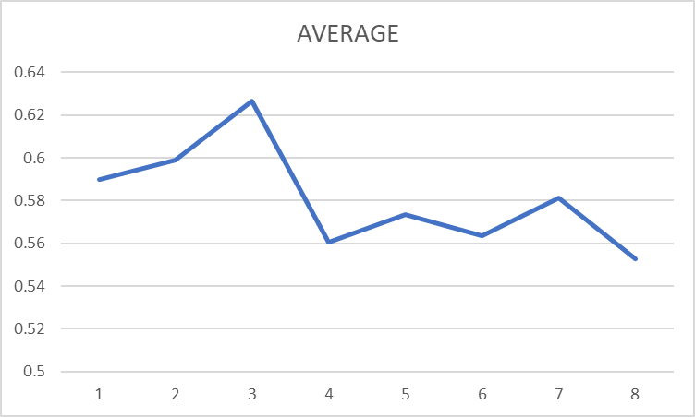

**INTERPRETATION:**

Over the average of a week, from January 31, 2023, to February 6, 2023, the sentiment analysis scores show how feelings changed. Imagine these scores on a line chart with each day showing if people felt negative, neutral, or positive. Something interesting happened on February 6, 2023 – there was a clear increase in positive feelings. The "AVERAGE" line helps see the overall trend, telling us how emotions shifted during the week. Looking at the chart, we can see subtle changes on different days, and these might connect to things happening outside. The chart's up-and-down lines represent the scores going from negative to neutral to positive feelings. This way of showing the information helps us understand how emotions changed during that time, giving us a better picture of the overall mood.

**Candle chart:**

|  |  |  |  |  |
| --- | --- | --- | --- | --- |
| Date | Open | High | Low | Close |
| 6-Feb-23 | 208.06 | 215.7 | 207.86 | 210.89 |
| 5-Feb-23 | 210 | 217.45 | 207.89 | 211 |
| 4-Feb-23 | 210 | 219.49 | 207 | 217.09 |
| 3-Feb-23 | 196.91 | 211.92 | 196.11 | 209.43 |
| 2-Feb-23 | 191.7 | 196.87 | 189.5 | 195.37 |
| 1-Feb-23 | 223.87 | 228.78 | 220.08 | 222.05 |
| 31-Jan-23 | 213.82 | 222.59 | 211.5 | 221.73 |

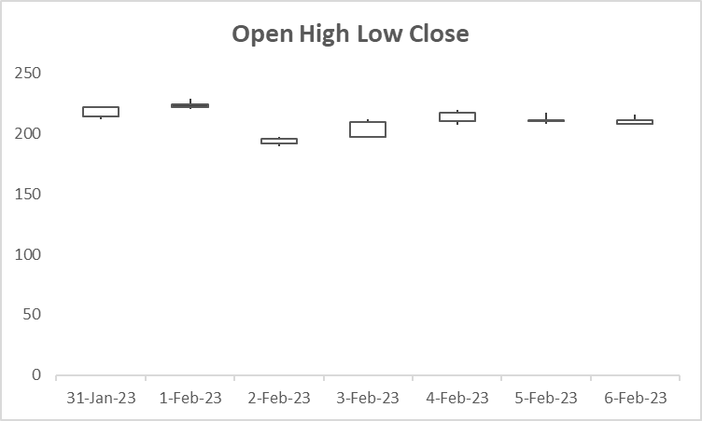

**INTERPRETATION:**

This table shows how the stock performed each day from January 31 to February 6, 2023. For each day, it gives the starting price (Open), the highest and lowest prices (High and Low), and the closing price (Close). Imagine a box-and-whisker plot as a way to picture this data. The "box" in the middle of the plot represents where most of the closing prices fall – it's like the middle chunk of the story. The line inside the box is the "middle" closing price. The "whiskers" on either side show how far the prices stretch, from the lowest to the highest, giving an idea of how spread out the prices are. If there are any prices that are really different from the rest (outliers), they would be shown as dots beyond the whiskers. Looking at this plot helps us see the overall pattern and how much the stock's closing prices changed during this week.

**COMPARISON**

The first paragraph of interpretation tells about how people's feelings changed each day from January 31 to February 6, showing a graph with lines going up and down to represent negative, neutral, and positive emotions. It points out a noticeable increase in positive feelings on February 6.

The second paragraph of interpretation is about how a company's stock prices behaved during the same week. It uses a graph called a box-and-whisker plot, where the "box" shows where most of the prices were, the line inside the box is the middle price, and the "whiskers" show how much prices varied. If there were any unusual prices, they would be shown as dots outside the whiskers. This helps us understand how the stock prices changed during the week.

**Positive Tweets and Stock Prices:**

* On February 6, 2023, there is a noticeable increase in positive feelings, and the stock's closing price is also higher than the previous days. This might suggest a positive correlation between positive sentiments and stock performance on that specific day.
* On February 5, 2023, there is a cluster of positive tweets, and the stock's closing price is relatively high.

**Negative Tweets and Stock Prices:**

* On February 6, 2023, there is a negative tweet, but the stock's closing price is still higher. This suggests that the impact of the negative tweet might not be significant on that particular day.
* On February 3, 2023, there are negative tweets, and the stock's closing price is lower, indicating a potential correlation